## HVAC Remote Basic Instructions

* **Ion:** Breaks up air particles & diminishes odor
* **ON/OFF:** Never turn your unit off. Always have the fan ON for air circulation.
* **Temp. :** Temperature Controls
* **Quiet:** This mode decreases the air flow. We recommend our residents not to use this function.
* **Fan Speed:** HIGH mode provides the maximum air flow.
* **High Power:** Boost air speed for approximately 15 minutes. This is recommended after taking a shower.
* **Flap:** Oscillating setting prevents moisture from accumulating and dripping from the unit.

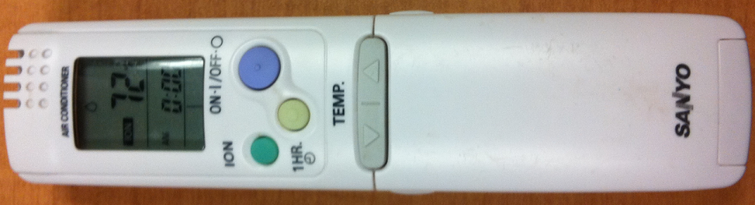 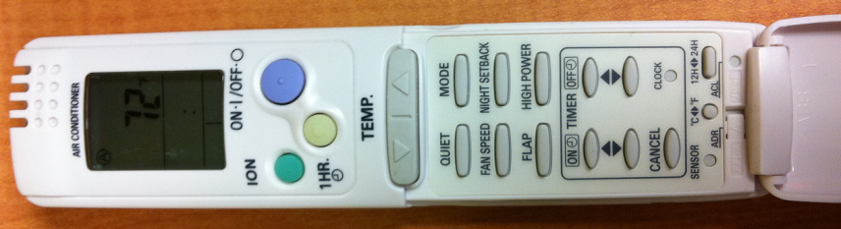

Pictured to the Left is the HVAC remote control. If you have multiple HVAC units within your apartment, you can use the remote with any one of the HVAC units.

To access the additional settings, open the bottom flap.

The MODE button allows the HVAC Unit to switch between settings. ***In apartments with more than one HVAC unit, all units must be on the same Heater or Air conditioning setting to function properly.***

1. **AUTO (letter A with a circle symbol):** Diminished airflow. *We recommend never using this setting.*
2. **HEAT (sun symbol):** Heater setting.
3. **Dehumidifier (rain drop symbol):** Dehumidifier setting is to be used if the apartment feels “damp”. We recommend residents who enjoy taking hot showers to use this setting after their shower.
4. **Air Conditioning (atom symbol):** Air conditioning setting. We recommend our residents to leave their HVAC unit on this setting.

 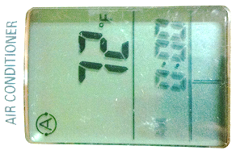 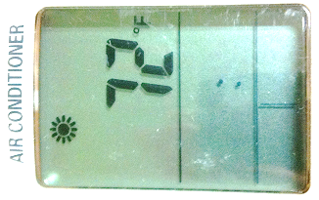 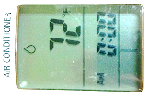 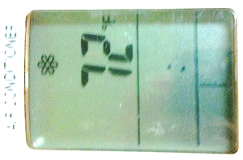

**1. 2. 3. 4.**